ASSIGNMENT 6.3

**DATASET:** 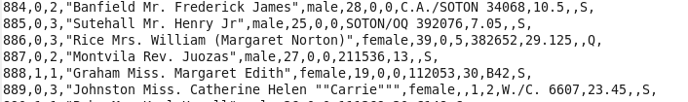

**DRIVER:**

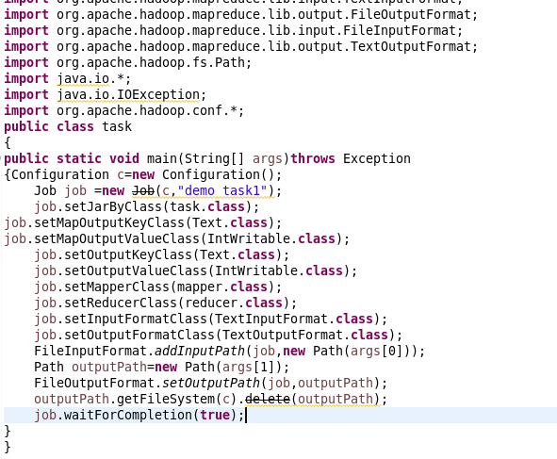

**REDUCER:**

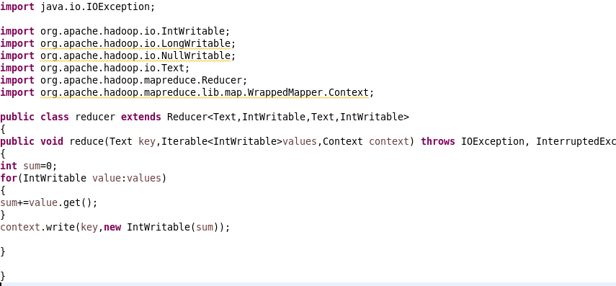

1. **Write a mapreduce program to find out number of males and females died in the titanic tragedy and save the output in KeyValue Output format.**

**MAPPER:**

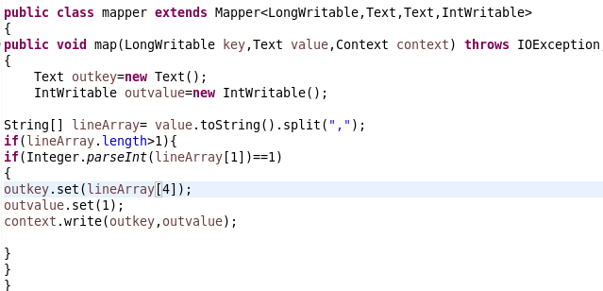

**OUTPUT:**

**C:\Users\612909\AppData\Local\Microsoft\Windows\Temporary Internet Files\Content.Outlook\DTK6JHGE\Capture.PNG**